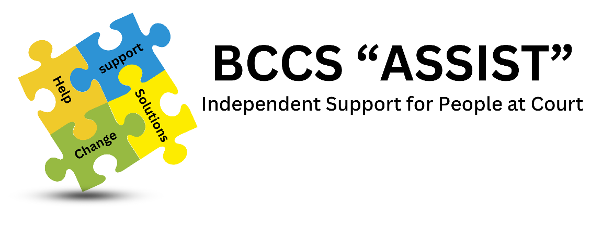
APPLICATION FORM – VOLUNTEER SUPPORT WORKER

Title: | Surname / Family Name: | Forenames:  Preferred Name: | Date of Birth:

Contact Details:

Home Address:

………………………………………………………………………………………………………

………………………………..…………..…………………………………………………………

Postcode: ………………………………………………………………………………………..

Tel Home: | Mobile: | Email:

Under our policies all applicants meeting the minimum criteria will receive equal consideration regardless of their age, gender, sexual orientation, religious beliefs, race or any special needs they may have. The information below is for monitoring purposes only.
Nationality:  ……………………………...  Ethnic Origin:  …………………………….. | Religious Belief:  …….………………….  Sexual Orientation:  …………………………. | Disability:  …………………………………  Please outline any special arrangements you will need to attend the interview.  ………………………………  …………………………………

Where did you hear about us? ………………………………………………………………….

BCCS Assist Volunteers
Our BCCS Assist Volunteers, following training, agree to undertake the role of a volunteer support worker (VSW) for minimum of 12 months. This involves working a minimum of one half-day every week - 3 hours minimum 09:30am – 12:30pm or 1.30pm – 4.30pm. During this time they will be available to take referrals from Magistrates, Court staff, Probation staff and clients’ self-referrals from any individual on court premises. VSW will receive no remuneration but will be reimbursed reasonable travelling expenses.

Your Availability Mon Tues Wed Thurs Fri
am pm am pm am pm am pm am pm

Are there any circumstances that will prevent you volunteering on a weekly basis?

…………………………………………………………………………………………………………

……..…………………………………….…………………………………………………………….

Present / Previous Occupation(s) (include child care & home management if relevant)

Please continue on separate sheet if necessary & attach to this application form

Voluntary Work Experience

Please continue on separate sheet if necessary & attach to this application form

Why do you wish to become a BCCS Assist VSW?

Please continue on separate sheet if necessary & attach to this application form

What can you bring to the role of VSW?

Please continue on a separate sheet it necessary & attach to this application form

Character References:
Please give the names of two referees who may be contacted to comment on your suitability for the role (including health). Please obtain the permission of the referee before submitting your form. One must be a former employer or equivalent. Previous employers, teachers, friends and neighbours, etc. would all be acceptable.
(Close relatives & those under 18yrs of age are not acceptable).

Referee Name (1): …………….………………………………………………………………….

Address: ………………………………………………………………………………………….…

…………………………………..…………………………………… Post Code: ..…………….

Email: …………………………………………….

Tel: …………………………………………… Mob: .…………………………..….....................

Referee Name (2): ………………………………………………………………………………..

ADDRESS: .…………………………………………………………………………………………

………………………………..……………………………………… Post Code: ..…………….

Email: …………………………………………….

Tel:……………………………………………… Mob:………………………….......................

Rehabilitation of Offenders Act (1974) Exemption Orders
Because of the nature of the work for which you are applying, this post is exempt from the provisions of Section 4(2) of the Rehabilitation of Offenders Act (1974). Applicants are not entitled to withhold information about convictions which for other purposes are “spent” under the provisions of the Act and, in the event of discovery of failure to disclose such convictions; BCCS Assist reserves the right to end the placement of the VSW concerned. All information given below will be completely confidential and will be considered only in relation to an application for positions to which the order applies. Please disclose any convictions below to include date of conviction, offence and penalty or sentence:

…………………………………………………………………………………………………………

…………………………………………………………………………………………………………

Screening of Volunteers
It is the policy of the BCCS Assist to assess the suitability of all volunteers applying to work in the service by requesting advice and information from the authorities as deemed appropriate. This will normally take the form of a Disclosure and Barring Service (DBS) check along with any follow up enquiries as appropriate. All information received from this source is strictly confidential.

I hold a current Disclosure & Barring Service Certificate: Yes / No

If, answered No to above, I am / I am not happy for my name to be put forward for screening by the authorities as deemed appropriate and I am able to pay the £15.00 administration fee for the DBS check. (Please delete as appropriate). NB. The £15.00 payable for the DBS check is fully refundable after successful completion of the training programme and 20 volunteered sessions.

Security and Safety Declaration:
I fully appreciate the need for security within HMCTS and agree to comply with security screening on entry into the building. I agree to abide by any safety, security and other instructions given.

Signed:………………………………………………….. Date ………………………….

Please return to:
Ms Kirsty Gregory,
Bradford Court Chaplaincy Service, c/o Bradford Magistrates’ Court
The Tyrls,
Bradford BD1 1LA.
Email: info@bradfordcourtchaplaincy.org.uk Tel: 01274 722422.

