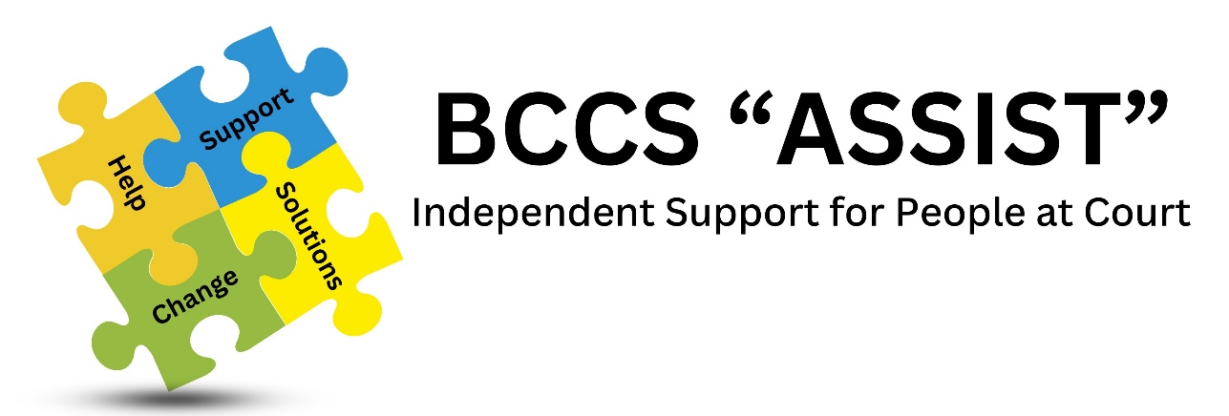

Confidentiality & Data Protection Policy

Approved by: Trustees 16th March 2023

Review Date: March 2026

Purpose:
It is essential that anyone using the services of the Bradford Court Chaplaincy Service (BCCS) feels certain that their confidentiality will be respected at all times. Service Users may be asked to sign a disclaimer, if it is felt that a BCCS team member needs to pass on their details to any other support agencies. The only exception to this is if the safety of a child or vulnerable adult may be compromised.

Trustees have taken note of the General Data Protection Regulations and taken appropriate action.

Policy Objectives:
This policy is intended to ensure that all Team members, (paid employees, volunteers, and anyone on work experience placement):
- are fully aware of the need to offer clients the assurance of total confidentiality
- appreciate that confidentiality means respecting an individual’s right to privacy and providing assurance that information will not be passed on to others without that individual’s informed consent.
- understand their duty to report concerns that arise about a child or young person / vulnerable adult, or a worker’s conduct towards a child / young person / vulnerable adult, to the named person for child and adult protection, i.e. the Team Leader (TL)

It is also intended to ensure that the named person for Safeguarding (Child and Vulnerable Adult Protection) is:
- competent to make the decision about if and when, confidentiality rules do not apply
- fully aware of the need to report protection concerns to the appropriate agency.
- fully trained and is kept up to date in relation to protection and confidentiality issues.

Implementation:
- Team members will take great care, when speaking to clients, to ensure that privacy and confidentiality are maintained by speaking in a quiet voice, taking the client to an area where they cannot be easily overheard or speaking with the client in the quiet / prayer room or an interview room.
- Service users must be informed that confidential information will not be disclosed to anyone else, unless there is good reason to believe that to do so would place an individual(s) or the service at risk. In this case the service user will be told what is to be disclosed and to whom, unless to do so would create further risk. The team member must inform the Named Person for Safeguarding, i.e., TL as soon as possible. The TL has a duty to report the concern immediately to the appropriate authority and log details of the concern, along with – time, date, person spoken to – in a confidential file specifically for the purpose.
- Confidentiality is maintained within the Team.
- Data collected for evaluation purposes will be done so as to ensure the anonymity of the client.
- Computerised confidential data relating to team members will be stored on an office computer. Computerised files will be password protected and kept secure at all times.

- When team members leave all paper and computer records will be destroyed / deleted after a period of 6 months. Team members will be given the option to have their personal details destroyed / deleted immediately or after such shorter period as is agreed.

To achieve this BCCS will:
- Provide appropriate and on-going training for team members
- Ensure that all team members are aware of the policy
- Make clear to all team members that any breach of the confidentiality policy will be treated as a serious disciplinary matter which could result in dismissal.

Person Responsible:
Team Leader (TL) is responsible for ensuring that all paid staff are fully aware of the confidentiality policy.
Development &Training Coordinator / Worker are responsible for ensuring that volunteers, and anyone on work experience placement, under their supervision are fully aware of the confidentiality policy.

TL is responsible for contacting the Chair of the Trustees about any issue where confidentiality needs to be breached under the terms of this policy within 3 working days.

Other information:
This policy should be read in conjunction with the Safeguarding (Child and Vulnerable Adults Protection) Policy Statement. A copy of this is kept in the Policies file held within the BCCS Assist Office, Bradford Magistrates Court.

